GitHub URL:
https://github.com/isa99sv/csd-402#

Java JDK 25 Installation:
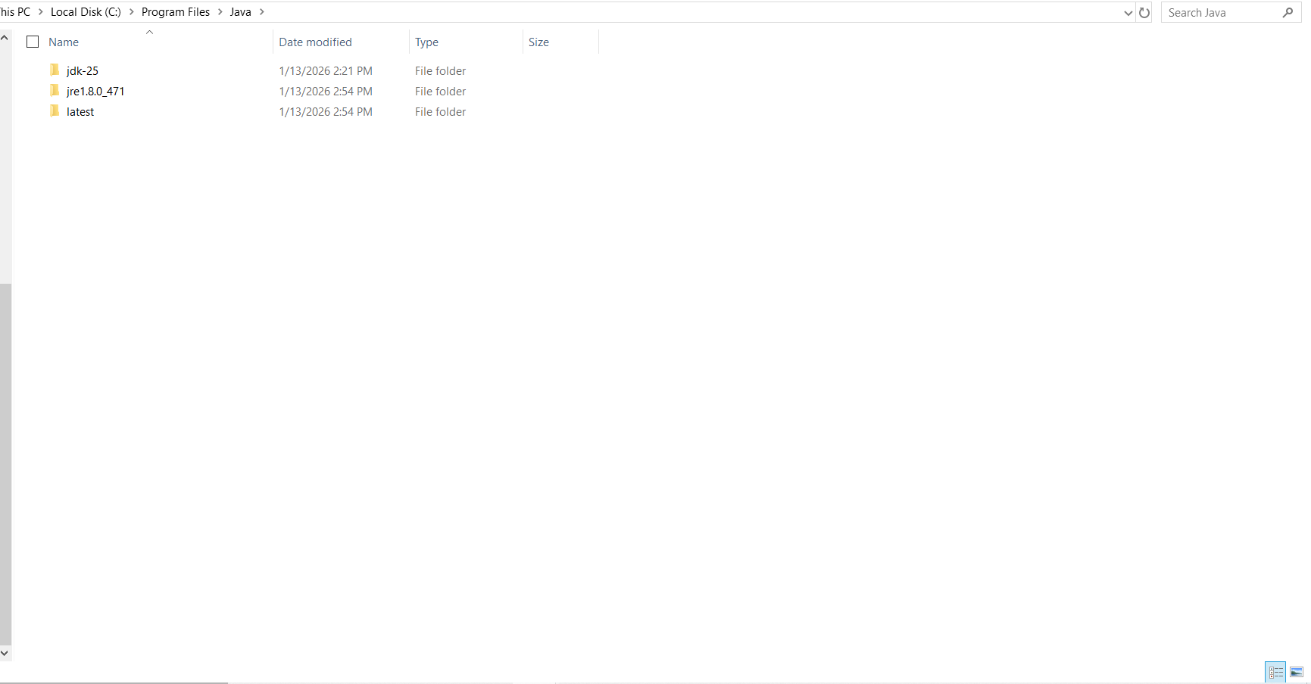

Java FX Plugin:
